Most cyclists are familiar with the concept of Functional Threshold Power (FTP). However, comparatively few know about or understand ‘critical power’, despite it being commonly used and preferred by many exercise physiologists and several cycling federations.
We believe that critical power testing can be used as a better alternative to FTP testing, offering several benefits and being based upon more robust scientific concepts.
In this article, we’ll be looking at what critical power is, why you might want to use it, and how to go about performing accurate testing.
If you’re looking to simply calculate your critical power and W’, click here to use our advanced Critical Power and W’ Calculator.

What’s Critical Power?
Critical power derives from the concept that the power-duration relationship above a certain ‘critical power’ follows a well-defined hyperbolic curve as shown:
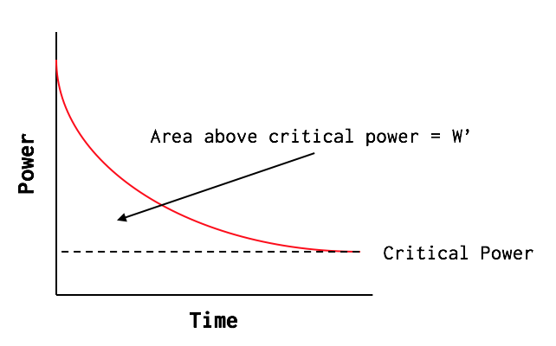
The curve can be defined by two parameters: the critical power (CP) and W’ (pronounced as ‘W prime’). We’ll take a look at each of these in turn:

Critical Power
CP is the power output that you’ll trend towards when riding at a high intensity, as exercise duration is increased ‘indefinitely’. ‘Indefinitely’ is a mathematical construct, and not actually true in practice, which is why this power-duration model fails to hold at or below CP. In practice, people can typically only sustain power outputs at CP for around 30-minutes (Vanhatalo et al., 2011).
Whilst it’s been shown that CP occurs close to the maximal lactate steady state (Poole et al., 2016), in most cases CP should not be used as a direct replacement for FTP (Karsten et al., 2021), which admittedly limits it’s direct application given almost all commercially available training platforms use FTP as their central power-based value to calculate intensity factor, training stress etc.
That said, we’ve found that taking around 96% of critical power as an FTP estimate generally works quite well for most individuals, especially if you also use your own subjective sensations to iterate your FTP and training intensity targets further (see e.g. this article).

W’
W’ (measured in kJ – i.e. units of energy) is the amount of work that can be done above the CP. It is a function of the VO2 slow component, VO2max, the depletion of limited intramuscular substrates (i.e. muscle PCr and glycogen) and the associated accumulation of fatigue-related metabolites, such as hydrogen ions, adenosine diphosphate (ADP) and and phosphate ions (Pi); each of which has been associated with impaired muscle contractile function (Poole et al., 2016).
W’ can vary widely. Endurance athletes will generally have a W’ that’s between around 9-15kJ for men, and between around 6-10kJ for women, although these values can be bigger for athletes with a very high VO2max. For more punchy endurance disciplines, slightly higher W’ are better suited – such as between 15-18kJ for men, or 11-13kJ for women. At the other end of the spectrum, sprinters can have W’ values in excess of 25-30kJ (Vanhatalo et al., 2011).
By performing a series of maximal efforts, each lasting somewhere between 3-mins and 20-mins, it’s possible to plot the relationship between CP and W’ and determine the values of these parameters.

Why Test CP and W’?
The obvious benefit of critical power testing is that it gives you two physiological markers from one test: critical power and W’. As the lactate threshold is a balance between the aerobic and anaerobic systems, knowing both CP and W’ can be useful in determining how best to balance these different parts of your physiology (read more on this here).
CP can also work better than FTP for setting training zones if you’re anaerobically stronger or weaker than the ‘norm’. That’s because common FTP test protocols (such as the 20-min test and the ramp/step test seen in popular indoor training platforms like Zwift and TrainerRoad) make assumptions about the extent to which the anaerobic energy systems contribute during the test, and can sometimes produce FTP estimates that are out by as much as 10-15%.
In contrast, the CP model inherently takes into account the amount of energy available over this threshold, and thus can produce better estimates of your maximal sustainable power if you happen to be notably anaerobically strong or weak.
Another significant benefit is that once you know your CP and W’, you can use the critical power equation (below) to predict the maximal power you could hold over various durations, or the length of time you could hold a given power (for durations between around 3 to 30-minutes). So, it can be useful for creating pacing strategies for measured efforts like hills climbs and time trials.
In the next section, we’ll look at how CP and W’ can be calculated. It’s not essential to understand the critical power calculations in detail, so you can skip over the next section if you wish. However, we’ve included the maths for those who are interested.

Calculating CP and W’
There are a range of methods for determining CP and W’, with varying levels of complexity and no accepted ‘gold standard’ approach (Maturana et al., 2018).
In our view, the most practical and easily-accessible approach is one where the power-duration relationship is transformed into a linear relationship, by plotting power against 1/time, as shown below.
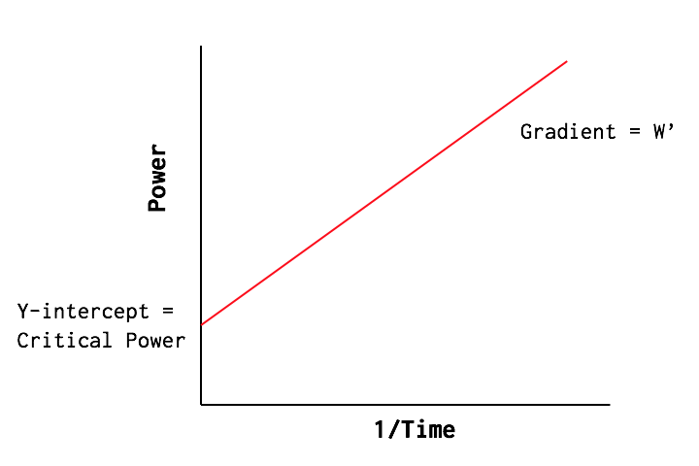
For those who are mathematically minded, the equation relating power and time then becomes:

Power = W’/Time + CP

By completing a series of maximal efforts, we can plot this linear power-duration relationship to determine W’ and CP, where CP is the y-intercept, and W’ is the gradient.
Several studies have proposed that CP and W’ can be determined from just two maximal efforts (Maturana et al., 2018; Simpson & Kordi., 2017). However, in our experience, using just two maximal efforts is highly sensitive to the specific powers and/or test durations used (making repeat tests hard to compare) and can result in fairly inaccurate estimates under certain circumstances. So, we recommend using 3-4 maximal tests to calculate CP and W’ accurately.
Let’s now look at how you can determine CP and W’ in practice.

Testing Protocols
In order to determine CP and W’, you will need to complete 3-4 maximal efforts, each lasting between 3-mins and 20-mins.
To get a good spread of durations, we’d recommend tests lasting 3-mins, 5-mins, and 12-mins, with the optional addition of a 20-min test.
The optional fourth test will help improve the accuracy of your results. The 5-min and 20-min test results can also be used to cross-reference your data with a power profile chart (see here), plus you can also cross-reference your CP with your FTP, as calculated from the 20-min test (see here).
Each maximal effort should be paced as consistently as possible. So, don’t start too hard, and then fade towards the end.
The tests should be performed on different days, with at least 24H rest between, so that your results aren’t impacted by fatigue. Completing multiple tests in the same day will tend to under-estimate your W’ value, because the W’ may not be fully reconstituted by the time you begin the second test effort.
Make sure you warm up well before each maximal effort. This is important because one of the assumptions of the critical power model is that the aerobic systems kick in instantaneously to provide energy during each maximal effort.
In practice this isn’t true, and there’s a lag between the effort starting, and the aerobic systems ramping up their energy contribution. However, this lag can be minimised by warming up well beforehand. Research looking at oxygen uptake after a warm-up (Jones et al., 2003) suggests a good warm-up should include:
- a gradual increase in exercise intensity from around a 2/10 to a 4/10 effort level or from around 45% to 75% FTP/CP/lactate threshold power.
- then some hard efforts above your expected FTP/CP/lactate threshold power, where you should feel lactate levels building somewhat, but these efforts these should only feel moderately hard, not all-out.
- then finally a short period (e.g. 4-5 mins) of gentle riding around a 2-3/10 effort level or between around 45-55% FTP to allow lactate levels to reduce.

CP Calculator
Test 1:

Test 2:

Test 3:

Input your test results in this section. Make sure you enter duration in seconds, and not in minutes!
If you only did two tests, then just enter results for Test 1 and Test 2.

Results - Two Test Solution
Critical Power (W):
Approximate FTP (W):
W' (kJ):
If you did two tests, your results will appear in this section. If you did three tests, you should read the results from the next section ('three test solution')

Results - Three Test Solution
Critical Power (W):
Approximate FTP (W):
W' (kJ):
Goodness of Fit (%):
If you did three tests, you should read your results from this section. We ideally want the 'goodness of fit' to be above 97%, which indicates your test efforts were all well-paced.

Pacing Calculator
Use this section to estimate the power you can hold for a given duration and vice versa. This only works for durations between 3-mins and 20-mins (180-1200 seconds). Make sure you look at the appropriate section (two test solution if you did two tests, and three test solution if you did three tests).
Enter Target Duration (s):
Estimated Power (W) (Two-Test Solution)
Estimated Power (W) (Three-Test Solution)
Enter Target Power (W):
Estimated Duration (s) (Two-Test Solution)
Estimated Duration (s) (Three-Test Solution)

Testing Tips
- Keep things consistent. Both our own experience and data from scientific studies shows that the length of the testing intervals can have a notable impact on your CP and W’ estimates (Maturana et al., 2018). So, if you’re trying to track changes over time, try to keep the length of the test intervals consistent each time you test.
- Be cautious when interpreting your results the first two times you determine your CP and W’, as these results will likely be less reliable due to sub-optimal pacing. Research shows that results become more reliable once you’ve completed the testing protocol at least three times (Simpson & Kordi, 2017).

Potential Limitations
Finally, to wrap-up this article, we should consider whether there are any limitations to critical power testing.
It’s worth mentioning firstly that like any field-based testing that demands maximal efforts to be produced, the results are highly sensitive to factors such as fatigue, motivation, nutrition and environmental conditions, which can influence performance on the day. There will ALWAYS be day-to-day differences in performance and your associated CP and W’ values. Try your best to control these confounding factors as much as possible.
We’ve already mentioned above that the test results are sensitive to testing durations and will be less reliable if you’re inexperienced with these test durations. But again, this is true of other field-based testing methods, such as the various protocols for determining FTP.
Ultimately, we think that critical power testing is one of the best field-based testing options, which can give more valuable physiological information that basic FTP testing, and which can be more accurate for athletes with notably high/low anaerobic capacities.

o
0:00
if we made a graph of power and time
0:02
where power is on the left and time is
0:04
at the bottom and then we asked you to
0:07
do a bunch of different tests where we
0:09
said right as long as you can as hard as
0:11
you can right as long as you can as hard
0:13
as you can right as long as you can as
0:15
hard as you can and so on
0:18
what you get is a bunch of points that
0:19
look like this
0:21
so you can see from the short periods of
0:23
time you can go way harder than you can
0:26
for the long periods of time
0:29
so what we can do is draw a line through
0:31
all of them now the interesting thing
0:35
here is when you draw the line it looks
0:38
like it levels out somewhere but the

CP
0:40
important thing is that that's critical
0:42
power or threshold power
0:44
and while it's been shown that critical
0:46
power occurs close to the maximal
0:48
lactate steady state in most cases
0:50
critical power should not be used as a
0:53
direct replacement for FTP which
0:55
admittedly limits the direct application
0:58
given almost all commercially available
1:00
training platforms use FTP as their
1:02
Central Power based value to calculate
1:05
intensity factor training stress Etc
1:08
but critical power is the level you feel
1:11
when you say okay I can do this for a
1:14
little while but if I go any harder I'm
1:16
going to blow up right away in practice
1:19
people can typically only sustain power
1:21
outputs at critical power for around 30
1:24
minutes so the other interesting thing
1:26
if we do look at the same graph as
1:29
critical power

W Prime
1:31
is that if we draw a little box so if we
1:34
make a box that connects the one axis
1:36
over to these points and down to
1:38
critical power line that area is called
1:41
W Prime it's a measure of energy
1:44
measured in kilojoules and as you can
1:47
see you can draw boxes around any of
1:50
these points and the interesting thing
1:52
is that they're always the same size
1:54
sometimes they're tall and skinny
1:56
sometimes they're long and skinny but no
1:59
matter what there's the same amount of
2:01
energy in each of these boxes
2:05
now what that means is that once you get
2:07
above your critical power you have a
2:10
very limited amount of energy that you
2:12
can expend and you can expend it really
2:14
quickly by going really hard or you can
2:16
expand it over a longer period of time
2:19
by going easier but either way you've
2:23
only got the same amount and if you use

W Prime Levels
2:26
it all up you're going to blow up or
2:28
have to slow down
2:29
and one of the things that you can think
2:31
of this is like a battery at the start
2:33
of your workout you've got 100 and if
2:36
you do intervals until you explode
2:37
you'll end up with zero percent left in
2:40
your battery and that's obviously
2:41
something you want to avoid especially
2:43
if you're in a race
2:45
when we measure W Prime we can compare
2:47
it to some typical levels for endurance
2:49
athletes for example this level is
2:52
around 9 to 15 kilojoules for men and
2:54
around six to ten kilojoules for women
2:56
although these values can be bigger for
2:59
athletes with a very high VO2 max for
3:02
Punchy endurance disciplines slightly
3:04
higher W Prime are better suited such as
3:07
between 15 to 18 kilojoules for men or
3:11
11 to 13 for women at the other end of
3:13
the spectrum sprinters can have W Prime
3:15
values in excess of 25 to 30 kilojoules
3:19
if you read the information that was
3:20
supplied with the test file you would
3:23
get an understanding of the types of
3:25
tests needed to get critical power and W
3:29
Prime but to roughly go over this you
3:31
need three or four maximal efforts
3:33
anywhere between two minutes and 20
3:36
minutes and there definitely are some
3:38
best practices around how this session
3:41
or two sessions should be run

Critical Power

Critical Power: jouw duurzame grens in watt
CP met W′ beschrijft je gedrag in het zware domein: wat je duurzaam kunt leveren en hoeveel boven-CP budget je hebt. Krachtige aanvulling op VT1/VT2 en VO2max.
Duurzame grensCP is waar je naartoe trekt als de inspanning langer wordt.
Boven-CP budgetW′ verklaart aanvallen, heuvels en surges.
PraktischHelpt pacing en intervalontwerp onderbouwen.

Wat CP en W′ zijn

CP
Duurzame grens in het zware domein. Boven CP geen echte steady state.

W′
Eindig boven-CP budget. Elke extra watt boven CP verbruikt W′ sneller.

Waarom relevant
Verklaart waarom je kunt aanvallen én waarom je kunt opblazen.

Als de visual niet laadt: CP = grens, W′ = budget boven die grens.

Critical Power-model (constante belasting)
Geldig bij constant vermogen boven CP. Boven CP wordt W′ lineair verbruikt; onder CP kan W′ herstellen.
CP is de steady-state grens; alles daarboven is non-steady en tijdelijk.
Jouw CP (W) 280 W
< 200 W: recreatief200–260 W: getraind260–320 W: competitief> 320 W: zeer hoog niveau
Indicatief, geen norm. Individuele waarden verschillen sterk.
Jouw W′ (kJ) 15.0 kJ Vermogen (W) 320 W
ΔP = P − CP
+40 W
Theoretische volhoudtijd (mm:ss)
6:15
W′ gebruik (kJ)
15.0 kJ
Doelduur (s) voor een klim / blok 360 s
Maximaal vol te houden vermogen
322 W
Bij constante belasting en volledige inzet.
ⓘ Critical Power is individueel en afhankelijk van trainingstoestand, testprotocol en meetmethode; waarden zijn niet 1-op-1 vergelijkbaar.
≤ CP: steady-state, W′ kan herstellen
> CP: non-steady, W′ verbruik
W′ herstel mogelijk onder CP
CP

Hoe wij CP meten

Efforts
3–4 max efforts in 3–20 min (bijv. 3, 5, 12, 20 min).

Kwaliteit
Bij voorkeur op aparte dagen; vermoeidheid vertekent vooral W′.

Model
We nemen de beste gemiddelde power per effort → CP + W′.
CP/W′ komt uit je power–duration gedrag en maakt expliciet wat er boven je duurzame grens gebeurt.

Wat betekenen de variabelen?

Vermogen (P, W)
- Mechanische energie per seconde (1 W = 1 J/s).
- Hoger vermogen = meer energie per tijdseenheid.
- Gemeten met vermogensmeter (crank/pedaal/naaf/trainer); kalibreer/zero-offset voor nauwkeurigheid.
- Onafhankelijk van snelheid of terrein.

Critical Power (CP)
- Hoogste vermogen dat langdurig vol te houden is zonder voortdurende uitputting.
- Grens tussen steady-state en non-steady-state (verwant aan VT2/MLSS).
- Typisch ±30–60 minuten vol te houden.

W′ (“W-prime”)
- Beperkte extra energie boven CP (kJ); model van anaerobe capaciteit.
- Verbruikt bij P > CP; kan (gedeeltelijk) herstellen bij P <= CP.
- Geen vaste “tank”, maar een modelmatige tijdelijke capaciteit.

P
- Gekozen of geleverd vermogen.
- P ≤ CP: steady-state mogelijk; P > CP: W′ wordt aangesproken.

Tijd (t)
- Duur (s) dat een vermogen wordt geleverd.
- Hoe groter ΔP, hoe sneller W′ opgaat en hoe korter de maximale volhoudtijd.

Formules (constante belasting boven CP)
- W′-verbruik: W′ = (P − CP) × t
- Volhoudtijd: t = W′ / (P − CP)
Alleen geldig bij constant vermogen; vereenvoudigd model.
In praktijk wisselt vermogen voortdurend; CP-model helpt plannen/begrijpen, niet exact voorspellen.
W′ herstelt alleen bij belasting onder of rond CP; hersteltempo hangt af van hoe ver je onder CP zit.

Casus: klim van ~6 minuten
CP = 280 W, W′ = 15 kJ. Bij 330 W is (P−CP)=50 W → tijd = 15.000/50 = 300 s (5:00) → te hoog voor 6 min. Bij 315 W is tijd ≈ 7:09 → realistischer.
Gebruik CP/W′ om pacing te plannen en intervalwerk te doseren.

Samenvatting
- CP = duurzame grens in het zware domein; W′ = boven-CP budget.
- Model: tijd = W′/(P−CP) en W′-gebruik = (P−CP)×tijd → direct toepasbaar.
- Meten met meerdere max efforts (3–20 min) levert reproduceerbare CP/W′.
- Gebruik voor pacing, intervalontwerp en om “opblazen” te voorkomen.
We zien je snel bij SportMetrics.

